- Logging into RUMTX gmail account
  - YouTube instructions: https://www.youtube.com/watch?v=YXd0jtouPr8
  - In your browser, go to gmail.com NOTE: DO NOT SHARE RUMTX USER NAME OR PASSWORD
    - User name = RUMTXC@gmail.com
    - PW = JWesley$1703
  - Click on “Inbox” on the left menu
  - 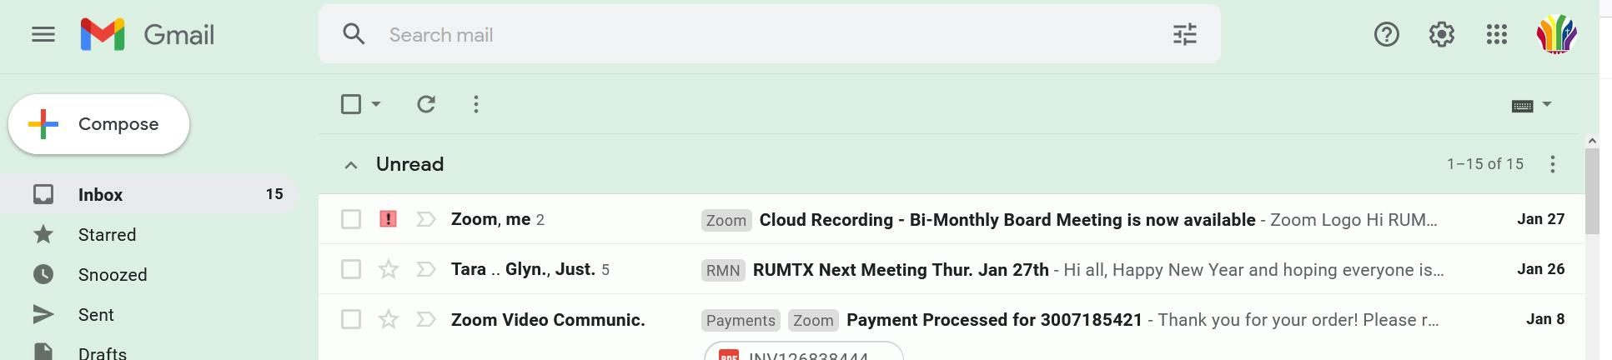
- Finding the Zoom Meeting recording
  - While in the Inbox, look for an email from ZOOM and is titled: Cloud Recording - Bi-Monthly Board Meeting is now available
    - Look at the email date to ensure it’s for the correct meeting.
  - 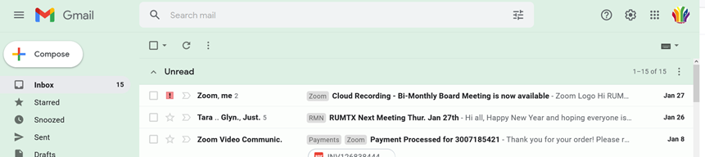
- Forwarding the zoom link
  - Open the Zoom email
  - Click on the 3 dots on the right side of the upper right corner
  - 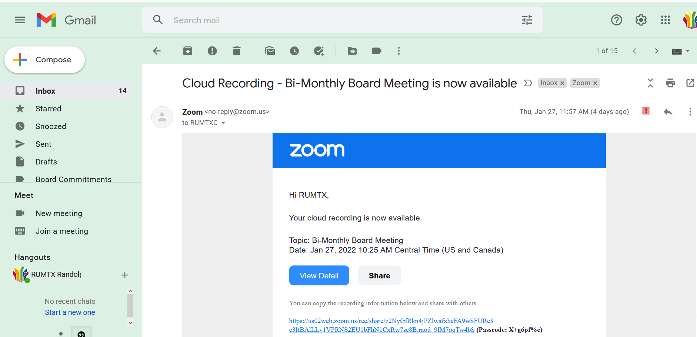

  - Select “Forward”
  - 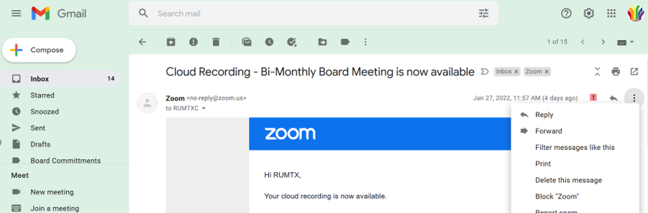
  - Put in your personal email address and click SEND
- Sign out of RUMTX email
  - Click on the RUMTX logo
  - Click on Sign Out
- Opening the Zoom Link once sent to your personal email
  - Open the forwarded email from RUMTX to you
  - Highlight and copy the password - do not include pre or post spaces or parenthesis
  - 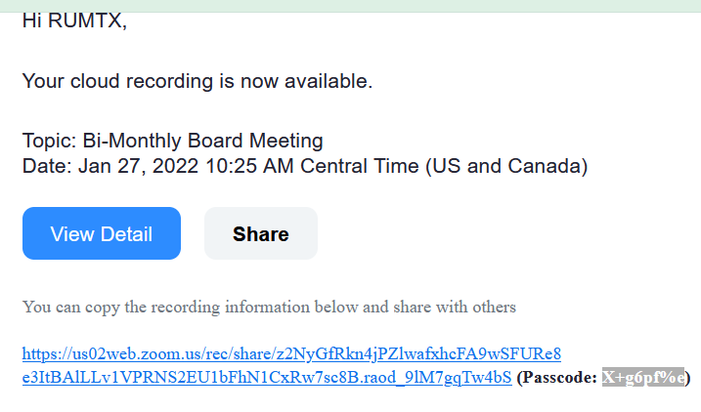
  - Click on the link in the email
  - This will take you to the Zoom screen. Place your cursor in the password box and right click. Select PASTE.

  - Click on View Recording
  - 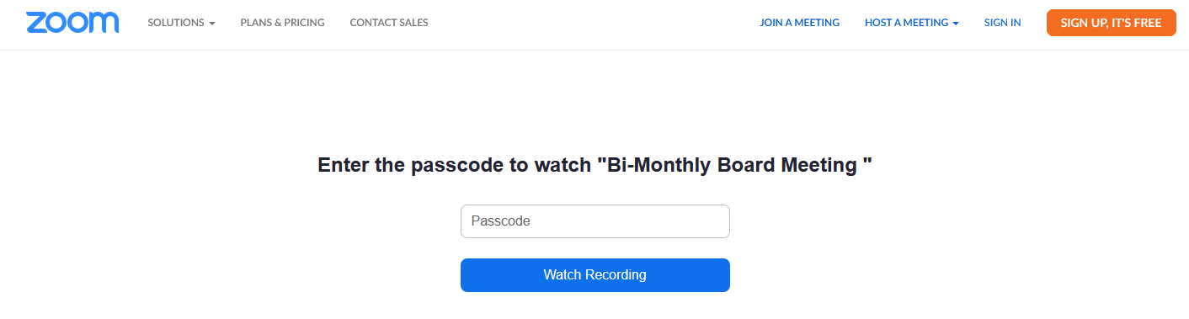
  - Once Recording is up:
    - , Start by clicking on the PLAY triangle.
    - Pause by clicking anywhere on the video.
    - Back up or fast forward by dragging the round circle on the timeline located to the right of the PLAY triangle forward or backward.

