- At start of meeting:
  - Ensure Host starts Record Meeting on Zoom at beginning of the meeting
  - Make a note of all in attendance during meeting as the recording will only show speaker view and NOT gallery view.
  - Make a note of the time meeting starts and ends.
- After meeting, the Zoom recording will be available anywhere from a few minutes after the meeting to a few hours. It goes to the RUMTC@gmail.com email account
  - Refer to the RUMTX PROCESS – Meeting Video Retrieval to access recording
- If you create a Minutes Template with current Board Member names it is much easier for attendance. 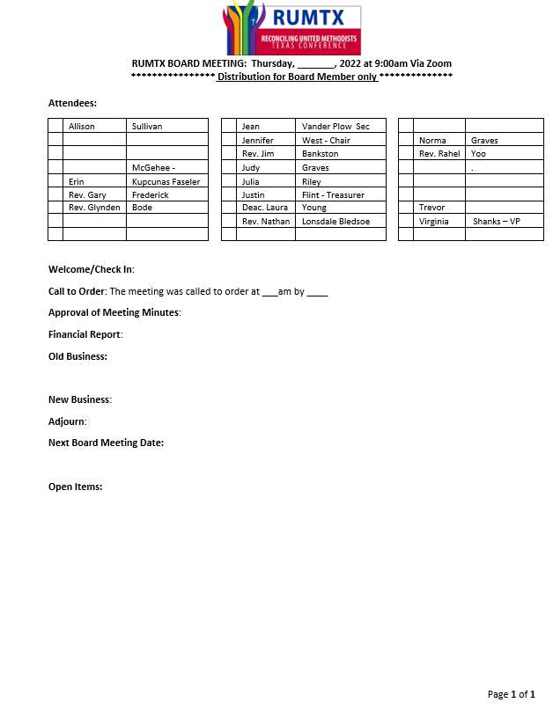
- Motions and To Do items
  - I tried to underline all Motions/Votes taken so they are easier to find.
  - I also tried to bold all To Do’s that were to be done by various members.
- Open Items:
  - This was used for items that were for the future or tabled during the meeting
- Distribution of Minutes
  - Minutes idealy are distributed as soon as possible after the meeting in case there are To Do’s for members and to ask for corrections – within a week of the meeting is good.
  - I did the minutes in Word, but distributed them as a PDF.
    - Pull up template and save in WORD as “(Date of Meeting) RUTMX Board Minutes” – Make sure to save in a folder specifically for RUMTX so it will be easy to find.
    - When minutes are finished and saved in Word then print and change printer to “Microsoft Print to PDF”
      - Click on Print
      - Click on the Printer down triangle to change
      - Click on Microsoft Print to PDF
    - 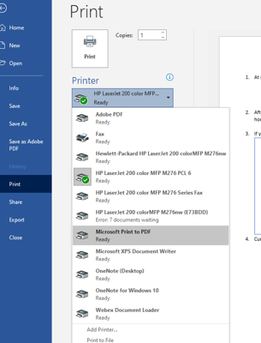
    - Name your pdf file as follows: “(Date of Meeting) RUTMX Board Minutes”
    - Save to your RUMTX folder
  - Current list of Board Member emails as of 1-31-22
    - You can copy and paste this list into an email. I also created a RUMTX Board mail group which I’m sure you can do in Yahoo as well.
    - Allison Sullivan <allisontsullivan@gmail.com>,
Erin Kupcunas Faseler <ekupcunas@yahoo.com>,
Gary Frederick <garyandjudy1964@gmail.com>,
Glynden Bode <glyndenbode@gmail.com>,
Jean Vander Plow <missnanajean2000@yahoo.com>,
Jennifer West <jcjwest@gmail.com>,
Jim Banston <jimbankston@yahoo.com>,
Judy Graves <jkgraves55@gmail.com>,
Julia Riley <julia@galvestoncentralchurch.com>,
Justin Flint <Flint@fortbendatty.com>,
"Laura (RUMTX) Young" <laura@rmnetwork.org>,
Nathan Lonsdale Bledsoe <nbledsoe@gmail.com>,
"Norma (Dick) Graves" <lexford10@aol.com>,
Rahel Yoo <Rahelyoo@gmail.com>,
RUMTX RUMTX <RUMTXC@gmail.com>,
Trevor Warnen <drummer.trev@gmail.com>,
Virginia Shanks hvholland2015@gmail.com
  - In the email make sure to ask everyone to proof the minutes and send corrects to your email.
    - If you receive corrections – make them on the Word version of the minutes; save file; and print to pdf again. (you can either save over the current names of docs or add a revision date to the end of the file name)
  - Note – the Secretary is the keeper of the minutes so do NOT delete the official copies.
- Duties of Secretary duties per By Laws:
  - 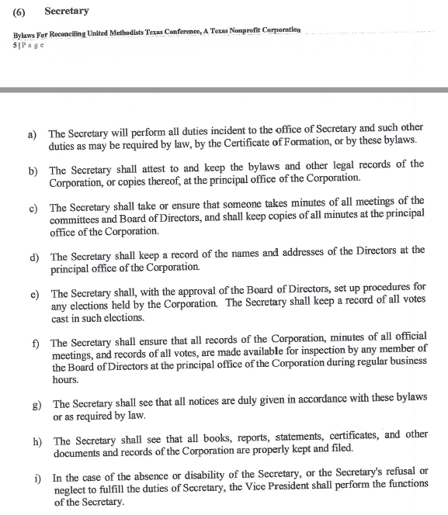
  - By Laws, incorporation docs are on a hidden page on the website as well.

