- Web page Subscription Info
  - https://www.rumtx.org/
  - Powered by Weebly
  - Paid for a 2yr Professional Site Plan with Weebly on 2/4/21which allows for unlimited storage, pw protected hidden pages and support via phone as well as chat.
    - 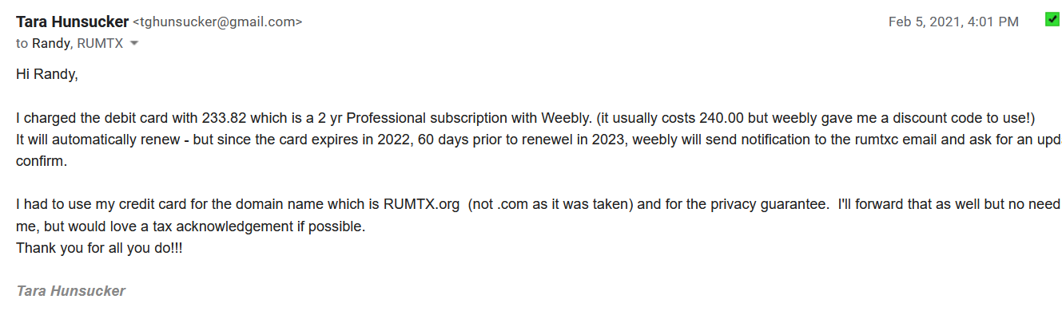
    - 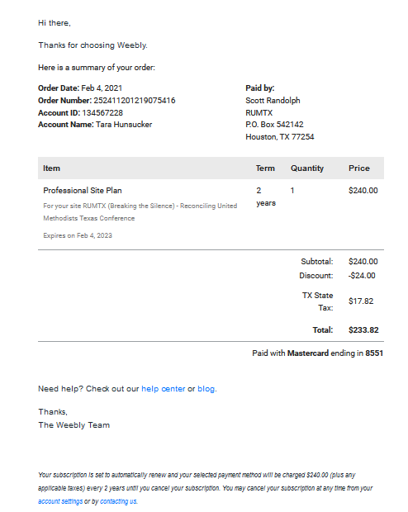
  - “Rented” the rumtx.org domain name on 2/4/21 for a 2 yr contract.
    - 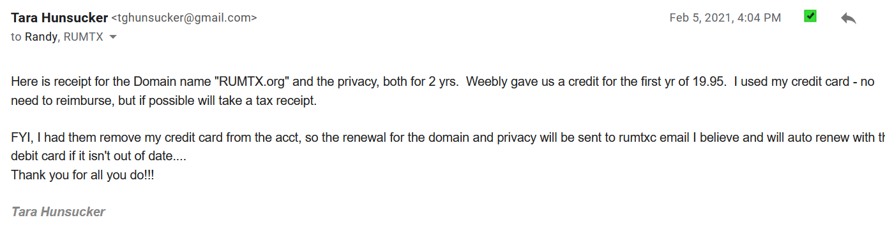
    - 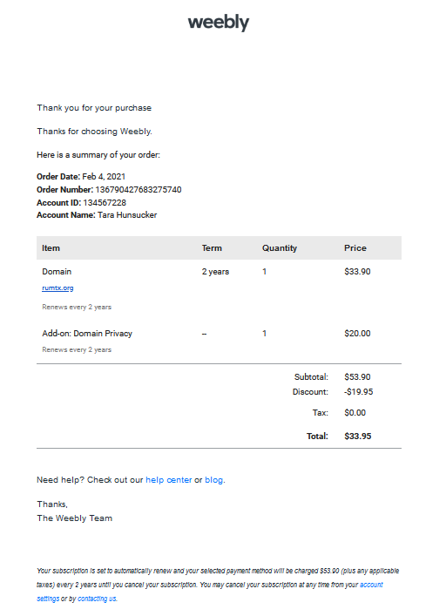
- To edit and see stats for web page
  - Login to https://www.weebly.com/
    - email = rumtxc@gmail.com
    - PW = rumTX!2020
- To change the list of Board Members
  - Update the Word Document list (also attached) and then use the Snip & Sketch app to save as a jpg picture. Save the jpg file as a unique name (I include the date of revision)
  - Login to weebly.com
    - On stat page in upper right corner click on the edit button.
      - 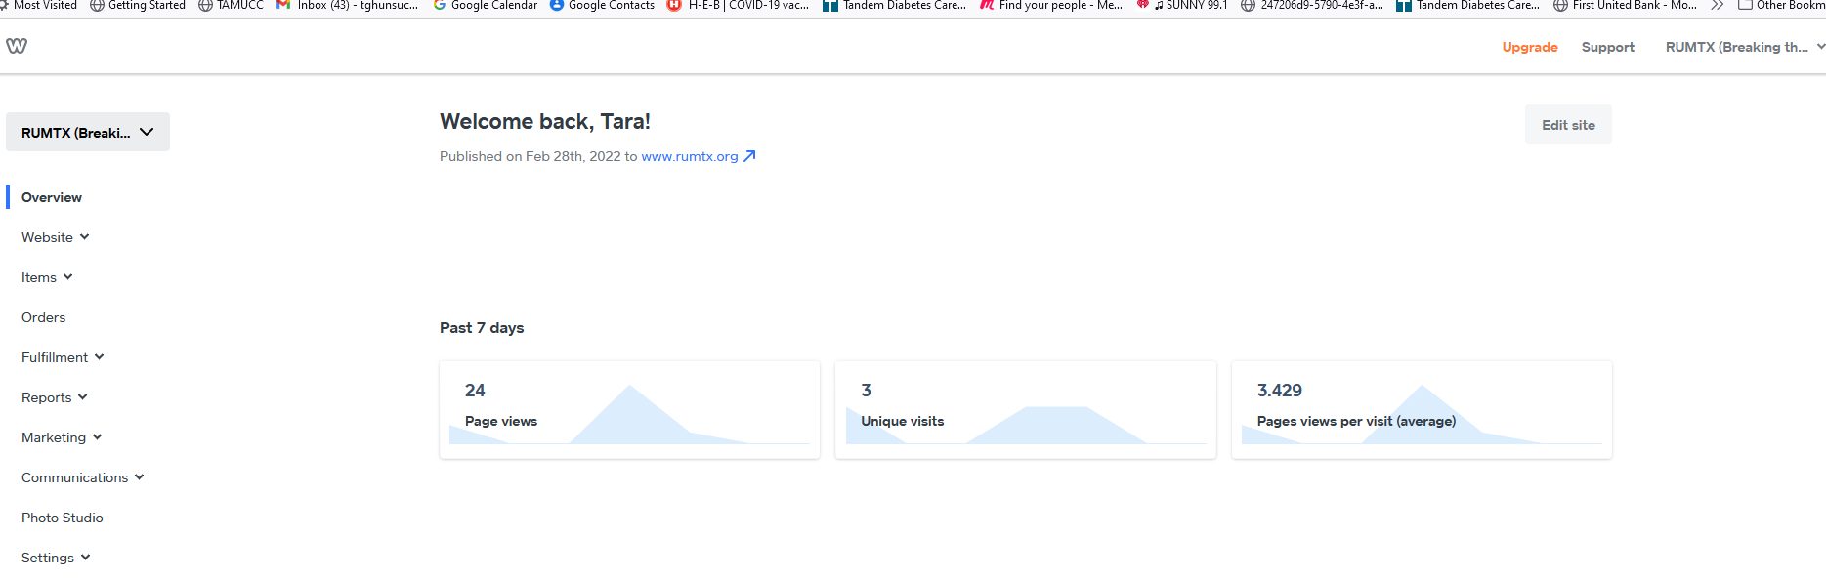
    - You will be on “Build” and on the Home Page.
      - 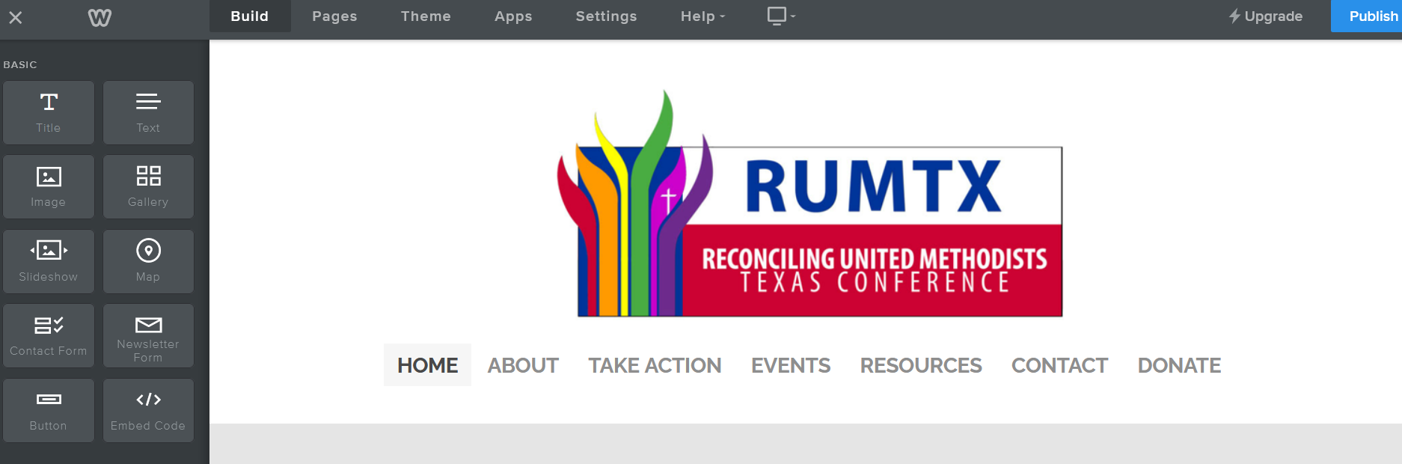
    - Hover ABOUT and click on OUR BOARD
    - You are now on the OUR BOARD page
      - Scroll down and right click on the current list of board members.
        - Select REPLACE IMAGE
        - 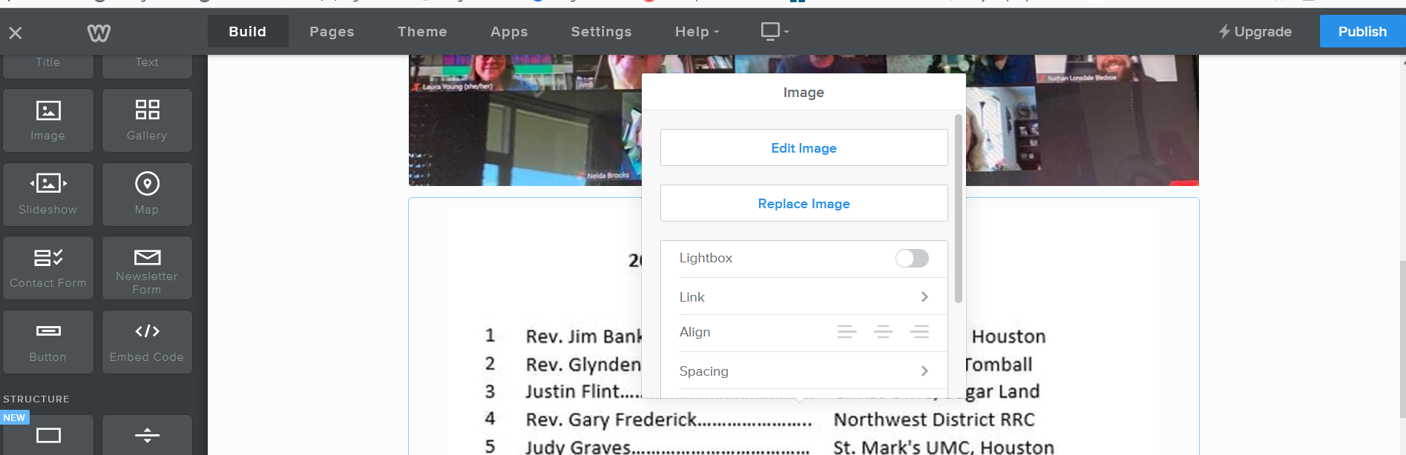
        - Then click on UPLOAD A PHOTO FROM YOUR COMPUTER, find where you saved the jpg file of the Word doc and click on it.
        - 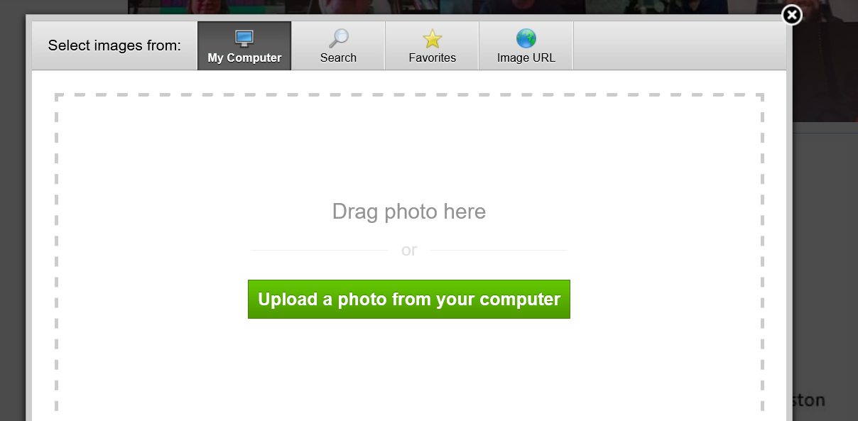
        - You can enlarge the picture by dragging a corner to increase size.
        - To finalize change – click on the publish button in the upper right hand corner. PLEASE NOTE - THIS WILL CHANGE THE ACTUAL WEBSITE – UP TO THIS POINT YOU HAVE JUST BEEN IN EDIT MODE.THERE IS NO UNDO BUTTON.
        - 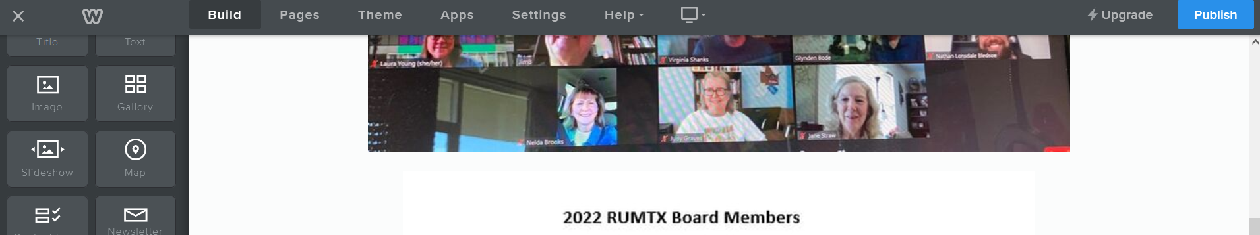
      - In another tab on your browser go to the RUMTX.org page to see your changes. You may have to hit F5 to refresh it, if it has been open during this change.
- To see a list of all pages including hidden ones
  - Go to PAGES on the menu bar of Weebly edit mode. On the left menu you will see a list of our pages for the website.
    - 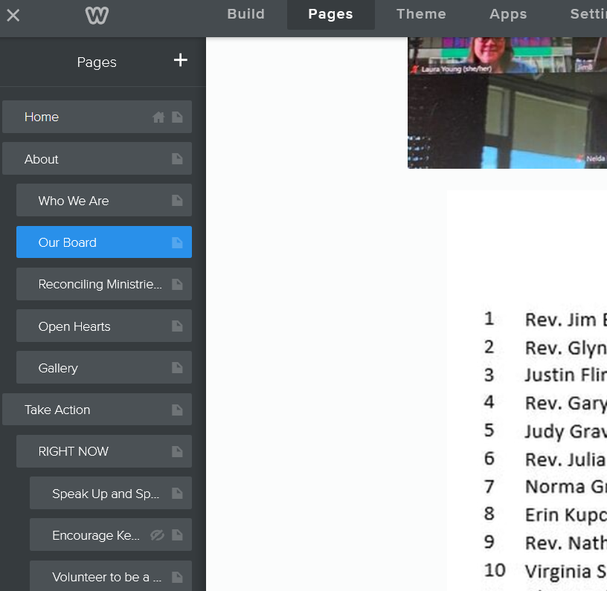
    - Please note that with our current subscription we can have hidden password protected pages. Our hidden pages are currently not pw protected – just hidden.
  - To hide a page
      - Click on the page
      - In the left hand menu, if the box for HIDE IN NAVIGATION is checked then page is hidden – uncheck to unhide.
      - 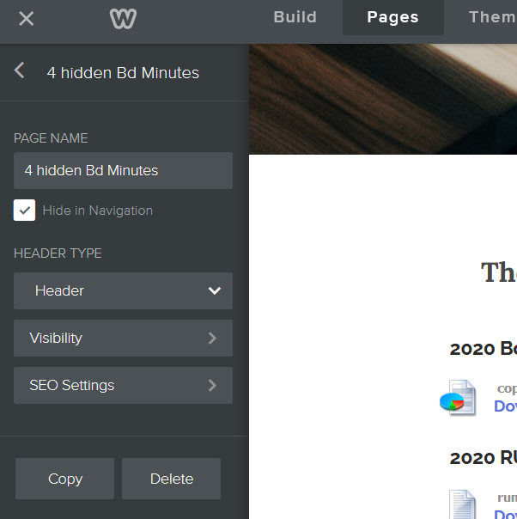
      - To set a password select VISIBILITY
      - To copy or delete page select COPY or DELETE on this same menu
  - Current Hidden Pages as of 2/28/22
    - RUMTX Bylaws
    - 1 Hidden Site Links – This is where documents reside are linked
    - 3 Hidden 501c3 docs
    - 4 2020 Hidden Bd Minutes – placed pdf file of minutes beginning in mid 2020 through Jan 2022.
    - Links from HOME page. This page is found through the link under IMPORTANT on the HOME page. It can be seen if link on HOME page is clicked on.
- Other Info
  - The live Chat works well and you usually have to go through it to get a number to call if you want to speak to a real person for help. Live person help is included in our subscription.
  - Many of our pages are pictures (jpg) of slides we used in our 2020 zooms. To edit that info you will need the original slide deck in ppt, save it to a new jpg after editing using snip & sketch app, then replace in webpage edit mode similar to board member list instructions.
  - Currently all links are published in a dark red font – to get them to be different from dark red I had to go through live help. It’s a settings thing.
  - Randy was the one that changed the website to accept registration monies and info, but I’m sure chat would be able to help with that.
  - VERY IMPORTANT – if doing a major revision of the website I highly recommend making a copy of the current one first (you will need to rename it). Then edit the unpublished version while keeping the “live” published version active.
    - Weebly allows you to have multiple websites (there is a limit) but we pay for just one to be published.
    - FYI, there is a limit of how many times you can move one website from another owner to this website – we’ve already done it once so that option should not be used unless you confirm it can be done again. This is important as some website designers will design under their name and then want to transfer to you – we may have maxed this option out already.
      - You can see the number of webpages we have on the stat page by clicking on the down arrow beside the name RUMTX BREAKING THE SILENCE. Note the other websites are noted as unpublished…

Tara Hunsicker’s phone number is 713-907-7001 if I can anser any questions.

